Issue 30–8th October, 2020

CALENDAR

OCTOBER
Oct 12 | All Students Return
Oct 22 | Footy Colours Day
Oct 23  Friday | ‘Thank You Day’ Public Holiday

HAPPY BIRTHDAY

Wishing the following
children a very
Happy Birthday!

29th September
Makayla 04M
Blake 06G

30th September
William 01F
Harley 02F
Benjamin 05L

1st October
Jordan 06S

3rd October
Lexie 03W
Aryanne 04O

4th October
Liam 06G
Darcy 06S

6th October
Harper 04P
Max 05RM

8th October
Angel B 04P

9th October
Zac 03W

PRINCIPAL TEAM REPORT
Dear parents and carers,
Following advice of the Victorian Chief Health Officer, the Victorian Government has released a staged approach for students to return to on-site schooling.
The purpose of the plan is to get students back in the classroom as soon and as safely as possible without putting at risk all that has been achieved through the period of restrictions to reduce the spread of coronavirus (COVID-19).
For our school, the following arrangements apply:
From 12 October (second week of Term 4) all students in Foundation to Year 6 will return to on-site schooling. The existing remote learning program will not continue.
On behalf of our school, we want to say a big thank you to all our students, parents and carers for your continued resilience and support throughout this year. We know remote and flexible learning has not always been easy, but through our collective efforts, our students have continued to make valuable progress in their learning. You can be confident that our school will support any student who has fallen behind to catch up.
Term 4 is important for every Victorian student, and our teachers will strive to deliver high-quality learning for everyone. Our focus for Term 4 is on making sure that every student is supported in their wellbeing, learning and transition needs.
We will be focused on three key priorities in Term 4:
Mental health and wellbeing
Our highest priority will be the wellbeing, particularly the mental health, of every student and member of staff. This means effectively mobilising all available resources to support our most vulnerable students and enabling staff to access the relevant support services.
Learning and excellence
Some of our students have thrived in the remote and flexible learning environment, others have maintained their learning progress, and some have fallen behind, despite their best efforts and those of their families and teachers. Our priority will be supporting both those who need it to catch up and those who have progressed to continue to extend their learning.
Transitions
We will make every effort to ensure successful transitions for children moving from kindergarten into Foundation and the Year 6s moving into Year 7.
Health and safety measures
As on-site schooling resumes, we will continue to have in place strong measures to protect the health and safety of students, staff, families and the community. This includes staggering start and finish times, restricting parent access to school grounds and continued emphasis on hand hygiene and physical distancing where possible.
Please give particular attention to reducing the risks associated with congregation at school gates and taking steps to contribute to physical distancing within the school.
IMPORTANT REMINDERS
A reminder that our BYOD portal is open for all parents of 2020 Year 3, 4 and 5 students. To avoid disappointment and ensure devices are delivered and set up for the commencement of the 2021 school year please proceed to the Portal. The link can be found by visiting our school website which has been recently updated. All the latest information on programs at our school can be found by visiting www.whittleseaps.vic.edu.au.
As students return to onsite learning on Monday there are several key reminders for all families. Firstly, in line with our Sunsmart policy, ALL students must wear a WPS school logo hat during break times, outdoor learning such as PE and preferably to and from school, especially when the afternoon sun is at its hottest. There are a few hats available for sale at the office for $15. We also have our ‘House Beanies’ for sale at the office for $15. If you don’t have yours yet you can also purchase one from the office.
Remember, you can always purchase other items of school uniform from Northern Regional Uniforms by calling 9436 4005. They will accept payment over the phone and deliver to our school on Thursday mornings.
Sunscreen will also be available to all students in classrooms, to apply before break times and outdoor learning such as PE. While WPS does purchase sunscreen that is suitable for sensitive skin, if your child requires a particular type of sunscreen, please provide a clearly labelled tube or pump bottle to be left in the classroom. Be sure to check the expiry date of the sunscreen. Please do not send along aerosol sprays.
As has been throughout the pandemic, drink taps will remain ‘off limits’ to students except for when refilling drink bottles. Please ensure your child brings a clearly labelled water bottle to school. WPS water bottles can be purchased at the office for $5.00. Students will be permitted to take water bottles outside during break times and to PE, particularly on days when the weather is warmer.
In keeping with this theme, students will be required to bring a pencil case to school to limit the ‘sharing’ of classroom materials. When students returned for a brief period in Term 2, they were required to bring a pencil case to school and all materials were supplied by the classroom teachers.
If your child took their pencil case home or you have collected it throughout Term 3, please ensure you pack it for Monday along will all remote learning books so that teachers can have a look through the learning that students have completed.
If you borrowed a school device for remote learning and access to Microsoft TEAMS, please return this to school with your child, fully charged, on Monday morning. As your child’s borrowed device came from your child’s classroom, it important we get these back into rooms for onsite learning as quickly as possible.
Book Week / Footy Day
As many of you would be aware, ‘Book Week’ would normally fall midway through Term 3 however this year it was postponed until to Term 4. To celebrate Book Week, things will look a little different with a number of planned school-based activities. While we cannot have a parade and celebrate with the community our teachers will be creating a ‘curious creatures, wild minds’ themed mask with students for a ‘Book Week’ celebration on Tuesday 20th October. Unfortunately, there will be no ‘Book Week’ dress up this year as we understand the ability to purchase or create costumes within a short time frame will be difficult due to the current stage 4 restrictions.
Despite this, we will be still holding our annual ‘Footy Day’ on Thursday 22nd October due to Friday 23rd October rebadged as ‘Thank you Day’ public holiday for Victoria. Warm jam donuts will be available for purchase for $1.00. Look out for your order form next week and get your footy gear ready!
The term ahead is a great opportunity to finish 2020 on a high note. Our teachers are planning to achieve the best outcomes possible in the remaining weeks and we can’t wait to bring our school together once again.
Until next week
Ty Hoggins & Rae Gittos
Principal Team.

CANTEEN/BREAKFAST CLUB NEWS

The canteen will be reopening next Thursday 15th October. There will be some extra precautions in place to ensure we are adhering to social distancing rules:
- We will have a timetable for over counter sales – one break for senior the other for junior

- Markings have been established for lines to ensure spacing between students

Please also remember that orders can also be placed online using the QuickCliq website.

Breakfast Club resumes on Wednesday 14th October.
SCHOOL CHAPLAIN REPORT

Peter Ackland - school chaplain

School History 1978 – Thomas Avelsgaard
Thomas Avelsgaard [1978-1983] was the Arts & Crafts teacher at the start of the school centenary year. He’s the smiling man below holding the shovel. For his centenary year contribution, he initiated a ‘grand design’ for hands on learning. Interested students were called on to construct a pioneer hut utilising a ‘Mud and Stud/Wattle and Daub’ historic building method thought to be used as early as 6,000 years ago. It involves wet clay-rich soil reinforced with straw and applied to a wooden frame. This mix was daubed onto the ‘wattle’ (horizontal lattice-like strips) which were attached to vertical stud frames. Many historic buildings included wattle and daub in their construction. Thomas Avelsgaard brought to life how the early Whittlesea settlers went about it.
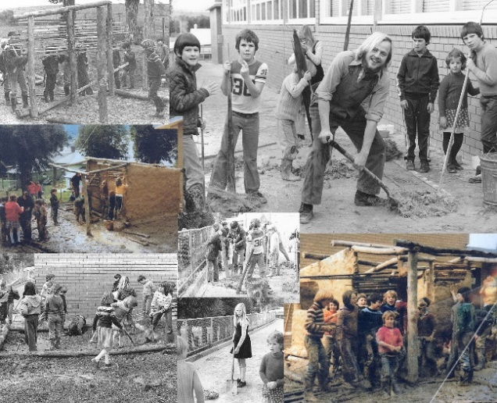

Mud was everywhere and most of the children enjoyed the chance to get acquainted with it. Many of the students those days lived on farms so it was less of a big deal. One of the necessary building materials was near at hand. The school oval of today had been gouged out of the hill behind and there was plenty of clay-rich soil for the taking. Bales of straw were easily supplied by farming families. This pioneer hut was successfully finished and sometime later it was removed. The location was exactly where the lawnmower shed is today at the north-western corner of the school property. Learning how to make the hut was of greater value than the product itself. Thomas Avelsgaard would certainly be missed when he moved on at the end of 1983.
To be continued…

FOOTY COLOURS DAY!

FOOTY COLOURS DAY IS COMING!

Thursday 22nd October 2020

You are invited to dress up in your favourite football team’s colours and participate in the festivities. Students will be participating in footy based learning tasks throughout the day.

If you dress up in your footy colours please bring a gold coin donation. Money raised will be donated on behalf of Whittlesea Primary School to Fight Cancer Foundation.

On the day, students have the opportunity to enjoy a hot jam doughnut, just like they do at the footy! Order forms will be handed out on the first day back and if you would like to order a hot jam doughnut, please return the form to school with the $1 payment by Thursday 15th of October.

No late orders will be accepted.

BYOD PROGRAM

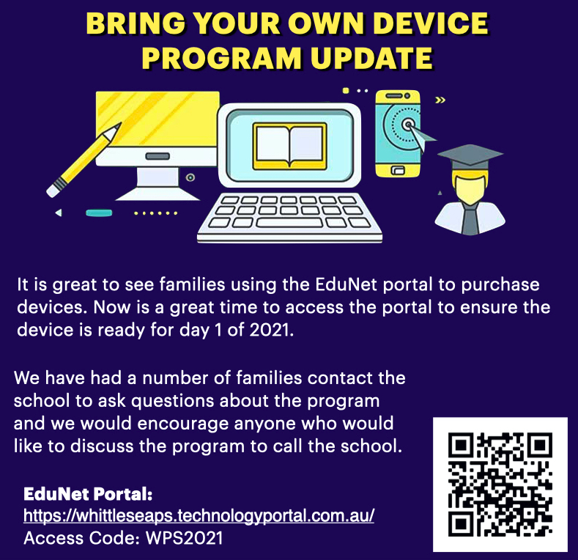

UNIFORM SHOP
